Mountmellick (MMKA)
Wednesday 14 January 2026
11:40

14 routines

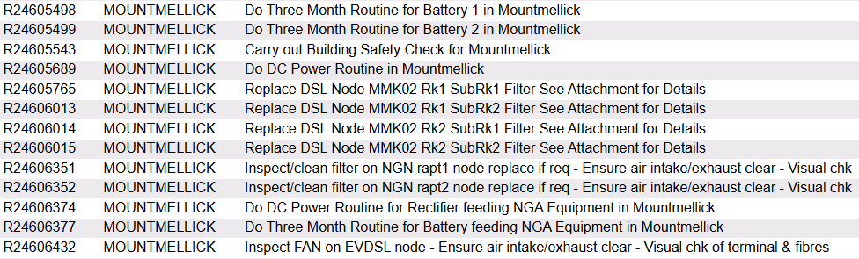

Please clean/replace filter on MMK-MSAN

Battery 2 has been removed

Do Three Month Routine for Battery 1 in Mountmellick

Overall Voltage: 53.57V
Temperature: 23 °C

Cell | 1 | 2 | 3 | 4 | 5 | 6 | 7 | 8 | 9 | 10 | 11 | 12 | 13 | 14 | 15 | 16 | 17 | 18 | 19 | 20 | 21 | 22 | 23 | 24
Voltage | 2.17 | 2.23 | 2.22 | 2.24 | 2.26 | 2.22 | 2.14 | 2.19 | 2.22 | 2.22 | 2.21 | 2.18 | 2.2 | 2.21 | 2.21 | 2.1 | 2.23 | 2.26 | 2.23 | 2.2 | 2.29 | 2.26 | 2.28 | 2.28

Do Three Month Routine for Battery 2 in Mountmellick

Battery has been removed.

Do DC Power Routine in Mountmellick

Rectifiers | 7
DC Power Load | 51.8
Boost Voltage | 53.5
Float Voltage | 53.94

Alarm Limits
Low Voltage | 46.3
High Voltage | 59.5
High Load | 80%
High Temperature | 30 °C

Low Voltage, High Voltage, High Load and High Temperature alarms were triggered,
but only Low Voltage alarm was visible to SMC

------------------------------------------------------------------------------------------------------------

Do Three Month Routine for Battery feeding NGA Equipment in Mountmellick

Temperature: 22 C

Battery 1
Overall Voltage: 54.25
13.54
13.55
13.54
13.55

Battery 2
Overall Voltage: 54.24 V
13.55
13.55
13.54
13.55

-------

Do DC Power Routine for Rectifier feeding NGA Equipment in Mountmellick

Rectifiers | 5
DC Power Load | 23
Boost Voltage | 54.5
Float Voltage | 54.2

Alarm Limits
Low Voltage | 47
High Voltage | 58
High Load | 80%
High Temperature | 28 °C

--------------------------

Low Voltage, High Voltage, High Load and High Temperature alarms were triggered,
but only Low Voltage alarm was visible to SMC

